目录

1 Docker File 1

1.1 How to build a Docker image from a docker file? 1

1.2 How to play with docker? 2

1.3 How to push to the docker hub? 2

2 Docker-compose: 2

3 Composing a Hyperledger Fabric Network 3

# 1 Docker File

Dockernize a nodejs webapp

Npm init

Npm install expressjs

Create app.js

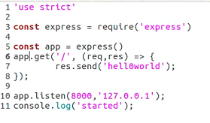

## How to build a Docker image from a docker file?

Dockerfile

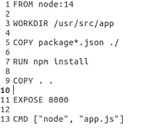

https://phoenixnap.com/kb/create-docker-images-with-dockerfile

docker build {docker file path}

docker build -t <your username>/node-web-app .

-t tag your image

Sudo docker image

Docker run -d --network=host <your username>/node-web-app

## 1.2 How to play with docker?

sudo docker ps

sudo docker logs --tail 10 xxx

sudo docker exec -it xxx /bin/bash (container interaction)

Curl -i 127.0.0.1:8000

## 1.3 How to push to the docker hub?

https://docs.docker.com/docker-hub/repos/

this is where we get all the fabric images

# 2 Docker-compose:

Dockernize a nodejs webapp

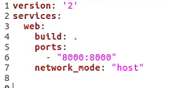

Docker-compose up -d

-d for daemon process

Remove network_mode and try

# 3 Composing a Hyperledger Fabric Network

Network.sh

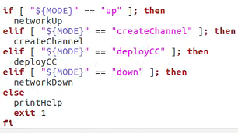

Search for networkup

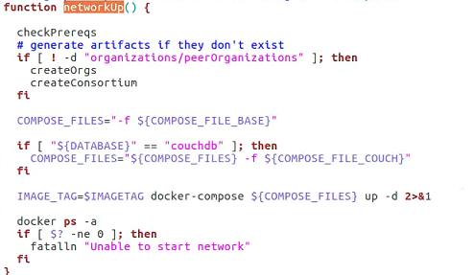

Check Prerequisite -> createOrgs -> createConsortium

Check Prerequisite: check if the program installed, and remove the ongoing docker image

createOrgs:



Generate template

./crpytogen showtemplate >> ss.yaml

./crpytogen generate --config=./ss.yaml --output=”orgs”

Common out the specs

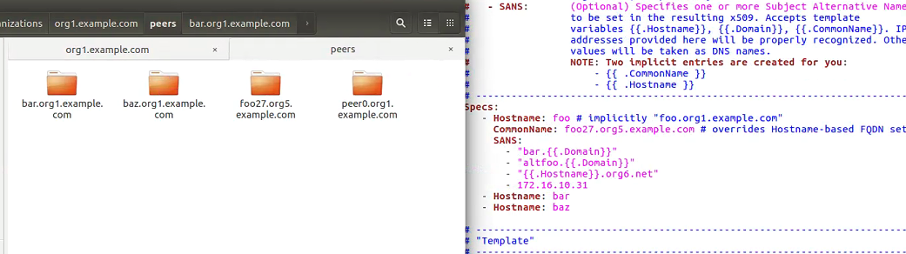

FABRIC_CFG_PATH is where to define the path of configtx.yaml